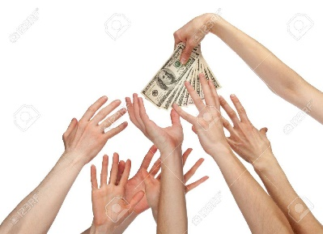**Kickstarter PROGRAM SAMPLE ANALYSIS**



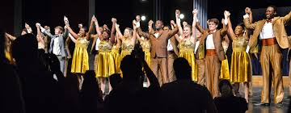| 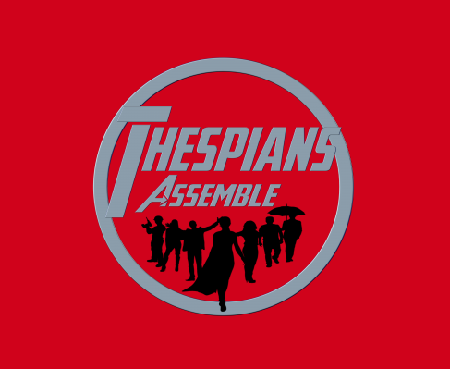 |  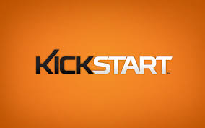Timothy J. DeRousse

Washington University

Data Analytics Bootcamp

Winter, 2019

**Kickstarter PROGRAM SAMPLE ANALYSIS**

**EXECUTIVE SUMMARY**

While Kickstarter has been an effective funding source for many projects, it is not for everyone. Analysis of 4114 projects suggests that theatrical plays have had some success in achieving project funding goals, especially when those project funding requests are launched in the spring; especially in May. Hardware projects also appear to see some success, although the sample of both those subcategories of projects may be too small to provide meaningful results. There are many limitations to studies performed on the collected data including the limited scope of the sample; slightly more than one percent of the population, and its particular relevance to the reader’s anticipated project. Even a theatrical play saw only a 65% success rate. While that is better than 50/50, it is not that much better. If the reader is interested in theatre and can develop the kickstarter campaign with little to no expense, then “break a leg !”

**PROJECT ABSTRACT**

There is limited availability of funding for new and innovative projects, especially for thinly capitalized and start-up companies. Many innovators and inventors turn to kickstarter for relief. This study analyzes the funding results of a sample of 4114 kickstarter projects out of the 300,000 kickstarter projects that have been started. The goal of this study is to discover trends generally prevailing in kickstarter funding programs so as to predict the success of future endeavors.

Each project seeking funding was categorized between film and video, food, games, journalism, music, photography, publishing, technology, and theater. Those categories were further allocated to a variety of subcategories. The funding request; the “budget” was compared to the aggregate actual amounts pledged to the project by patrons. Projects were analyzed as to the state of funding completion at the time of the study. The state of funding completion has been listed as “live”, “failed”, “successful”, or “canceled”. The percentage of budget funded was determined as well as the average funding per contributor. Each project’s time allocation was calculated and listed in order to demonstrate the rate of funding over time.

**Evaluation Findings**

The funding status per major category is displayed below:



Out of the study sample, a majority of the projects funded are in the performing arts. Film, Theatre, and Music have the greatest number of projects in the sample, comprising 63.5% of the number of projects sampled. Of the performing arts projects sampled, that combined group’s success rate is over 64%. While there are almost twice as many theater projects as music projects, the sampled music projects appear to be almost 17% more successful on average. The 24 journalism projects sampled appeared dismal at best, all of them having been canceled. Making up only one half of one percent of the sample, they might be considered an outlier and ignored. It should also be noted that just because a project has had a successful funding, does not mean that the project will ultimately succeed. In five cases, the project was fully funded, but was cancelled anyway.



If one were to further narrow the focus of the projects to subcategories, it appears that projects involving plays make up almost 26% of the projects in the sample. With a success rate of 65%. This seems to support what one might conclude at first glance that plays seem to be the project of choice among kickstarter project supporters. If one were to take on other projects in the theater category, one might expect to be successful only about half the time.

Documentary films and television projects appear to meet their goals, but animation and drama projects generally fail, unless the project is an animated short film. In technology, hardware projects do very well at 100% funding, while wearable technology and web projects are a bust.



Another issue explored in analyzing the sample of kickstarter projects is timing. More specifically, the study asks, “What is the expectation for success (at least 100% project funding) for projects started at specific months of the year?” The above graphical representation suggests that late spring into summer is the “normal” launch time for kickstarter projects, although successful projects tend to be launched in the earlier part of that scheme. The data also suggests that when supporters are spending in the shopping season, they are not spending on kickstarter projects. Success appears to plummet from November through year end. The optimal time to launch a kickstarter project appears to be May.

**Notable Limitations and Additional Studies**

* There are 4114 projects in the study’s sample. Initial project beginning information stated that there have been at least 300,000 kickstarter campaigns. The study sample comprises only slightly more than 1% of the population. It is uncertain that the sample truly reflects a random sample or a representative sample of kickstarter projects in general.
* There is no indication in the study’s initial data that
* The data suggests that even successfully funded projects as determined by the project’s initial funding request may be cancelled. There are 5 instances of this fact in the sampled data. This fact suggests that there are many other factors that are not considered in the analysis parameters that may affect the results.
* Additional charts and tables should be developed which demonstrate funding success over various periods of time. The current study analyzes the most beneficial month for a project launch. There may be some benefit in analyzing success of funding in various categories over the years. Trends may be cyclical in terms of public interest or they may demonstrate “fads” that come and go. Technological advances over time may also affect the attractiveness of projects in studied categories. A historical analysis may shed light on this issue.
* Sampled projects may not be relevant to a particular reader when considering kickstarter as a potential funding source. There may be increased benefits to first limiting the population of projects to only categories representative of the reader’s anticipated project category. A random sample of that modified population may provide better insights as to the potential effectiveness of a kickstarter funding campaign.
* The analysis does not study the success of projects as a function of their ambition. In other words, it does not answer the question, “How large of a funding request is too large?” This may be important to a reader in determining the target size of a funding request, or it may suggest the need for modification of the project. A reader may chose to break a project into smaller increments or to combine projects into larger funding requests. Analysis should be developed to determine the optimal project size for various categories.
* A cost/benefit analysis would also be very helpful in analyzing kickstarter programs as a source of funding.

**CONCLUSIONS**

If the sample set of 4114 kickstarter projects is truly a representation of the universe of kickstarter projects, the sampled data suggests that kickstarter as a funding source is most preferred by theatrical endeavors, especially by those funding plays. The data also suggests that the most successfully funded projects launched their kickstart funding programs in the spring; most often in May. There are many other factors that should or could be considered in the analysis of the collected data that may be of benefit in uncovering additional trends that might aid a reader in making decisions as to the funding of their anticipated projects.

SOURCES:

All data provided by Washington University Data Analytics Bootcamp Program, St. Louis, Missouri, Winter, 2019

Cover images captured from Google images

“Sitting Duck” by Michael Bedard